PURPOSE: To ensure e-mails for ACH / RMT and GBILL are received

DEPARTMENT | ACTION
Operations | DOC1 Monitoring – ACH / RMT  A. First: Look for two e-mails in outlook (should come in around 4:30m)  - The following subject line:  -" /s2prod/cdunix/eds/gbill_prod/D3OGACH1_010208164052.txt ... "  -" /s2prod/cdunix/eds/gbill_prod/D3OGRMT1_010208164554.txt... "  - If these fail or don't show up within an hour (by 5:30pm)  -An email (no phone call is necessary) needs to be sent to Tom Merrer, Greg Harada, Tina Waldrep, Thomas Gardea, and CC Operations  - FYI – Also associated with DOTCOMs for Group Bill ".  -If you see this e-mail, Internet Timings is not necessary. Joe Zimmerman.  B. Second: Look for e-mail GBILL (should come in around 8:30pm except on Saturday and Sunday) (no e-mail since Dec 2015)  - Log on to AIX1 with putty and log in.  - cd s2prod/online/doc1_eds/archive  - ls –ltr or ls -ltr *BILL* or ls -ltr *BILL* | grep "May 20"  - scroll up and look for GBILL file.  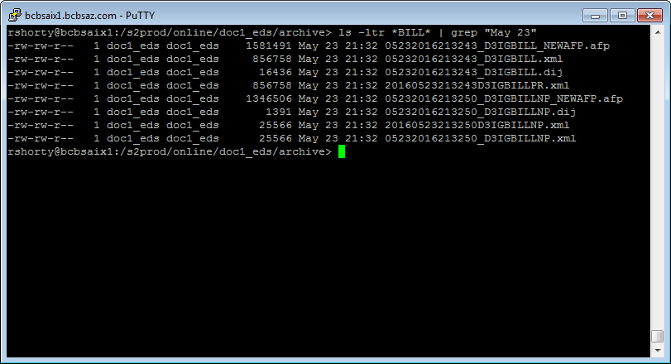  Note: Any issue, point of contact is HP Primary (Beth Kitts). In addition, an email needs to be send to Val Baldenko and CC Operations, reporting the issue and if it was resolved

